**Selenium Locators Assignment:**

**Problem 1**- Open 4 web

|  |
| --- |
| [https://phptravels.net/api/uploads/globallogo.png](https://phptravels.net/api/uploads/global/logo.png) |

site and locate the following and Write xpath.

* PHPTRAVLES Logo -  
  Relative Xpath = “//*[@id="fadein"]/header/div[2]/div/div/div/div/div[1]/a/img”  
  Absolute Xpath = /html/body/header/div[2]/div/div/div/div/div[1]/a/img
* Home

Relative = //*[@id="fadein"]/header/div[2]/div/div/div/div/div[2]/nav/ul/li[1]/a

Absolute = /html/body/header/div[2]/div/div/div/div/div[2]/nav/ul/li[1]/a

* Flights

Relative = //*[@id="fadein"]/header/div[2]/div/div/div/div/div[2]/nav/ul/li[3]/a

Absolute = /html/body/header/div[2]/div/div/div/div/div[2]/nav/ul/li[3]/a

* Tours

Relative = //*[@id="fadein"]/header/div[2]/div/div/div/div/div[2]/nav/ul/li[4]/a

Absolute = /html/body/header/div[2]/div/div/div/div/div[2]/nav/ul/li[4]/a

* Company

Relative =//*[@id="fadein"]/header/div[2]/div/div/div/div/div[2]/nav/ul/li[8]/a

Absolute = /html/body/header/div[2]/div/div/div/div/div[2]/nav/ul/li[8]/a

* Signup Btn

Relative = //*[@id="fadein"]/header/div[1]/div/div/div[2]/div/div/a[1]

Absolute = /html/body/header/div[1]/div/div/div[2]/div/div/a[1]

* Login Btn

Relative = //*[@id="fadein"]/header/div[1]/div/div/div[2]/div/div/a[2]

Absolute = /html/body/header/div[1]/div/div/div[2]/div/div/a[2]

* Agents DropDown

Relative = //*[@id="agents"]

Absolute = /html/body/header/div[1]/div/div/div[2]/div/div/div[4]/div/button

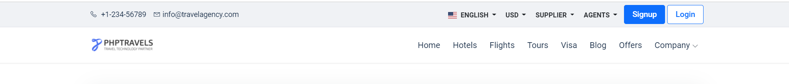

*Note - You have to use Id, Name, Class, CSS Selector, TagName and write Relative and absolute xpath*

**Problem 2**- Write **Xpath** for Below Web elements using Xpath Axes (such as preceding, following, ancestor, following-sibling etc..)

* Check in - Calendar Icon   
  //*[@id="hotels-search"]/div/div/div[2]/div/div[1]/div/child::span
* Check Out – Calendar Icon

//*[@id="hotels-search"]/div/div/div[2]/div/div[2]/div/child::span

* “- ” for Adults

//*[@id="hotels-search"]/div/div/div[3]/div/div/div/div/div[2]/div/div/div[1]/child::i

* “+” for Adults

//*[@id="hotels-search"]/div/div/div[3]/div/div/div/div/div[2]/div/div/div[2]/child::i

* “-“ for Childs

//*[@id="hotels-search"]/div/div/div[3]/div/div/div/div/div[3]/div/div/div[1]/child::i

* “+” for Childs

//*[@id="hotels-search"]/div/div/div[3]/div/div/div/div/div[3]/div/div/div[2]//child::i

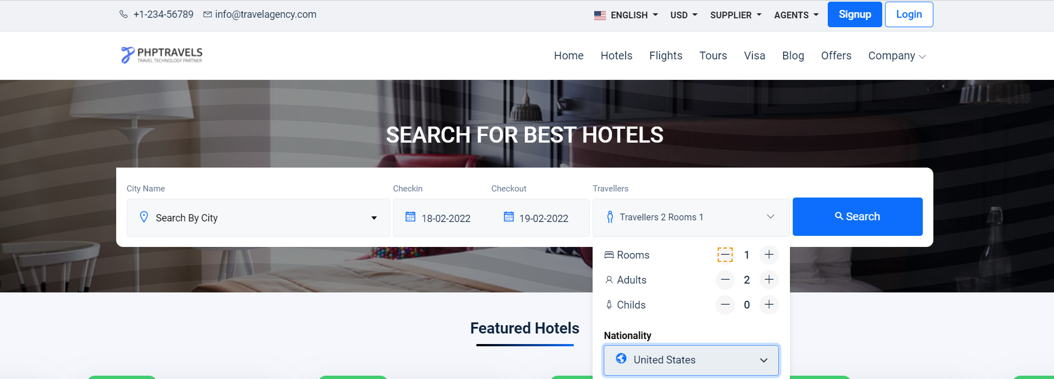

**Note : Don’t Use Indexes**